MUHAMMAD BIN AHSAN

SEC A   
468098

LAB TASK 1

#include <iostream>

using namespace std;

int main()

{

int i,j,k; int

array[3][3]; int

sum1(0),sum2(0);

cout<<"enter elements\n";

for(i=0;i<3;i++){

for(j=0;j<3;j++){

cin>>array[i][j];

}

}

cout<<"your array is \n";

for(i=0;i<3;i++){

for(j=0;j<3;j++){

cout<<array[i][j];

}

cout<<endl;

}

cout<<"left diagonal \n";

for(i=0;i<3;i++){

for(j=0;j<3;j++){

if(i==j){

cout<<array[i][j]<<endl;

sum2+=array[i][j];

}

}

}

cout<<"right diagonal \n";

for(i=0;i<3;i++){

for(j=0;j<3;j++){

if(i*j==1){

cout<<array[i][j]<<endl;

sum1=sum1+array[i][j];

}

else if(i-j==2){

cout<<array[i][j]<<endl;

sum1=sum1+array[i][j];

}

else if(i-j==-2){

cout<<array[i][j]<<endl;

sum1=sum1+array[i][j];

}

}

}

cout<<"sum of right diagonal = "<<sum1<<endl;

cout<<"sum of left diagonal = "<<sum2;

}

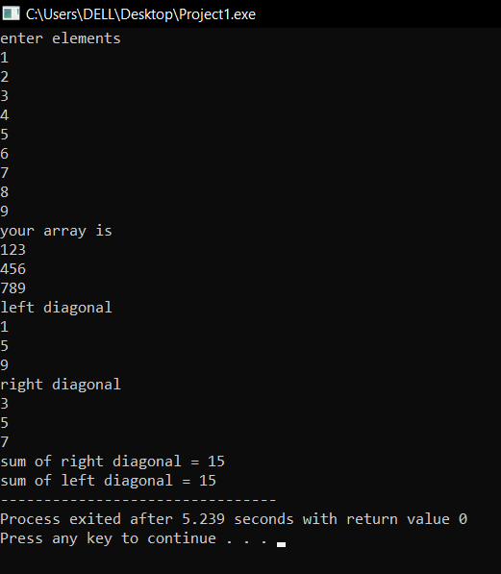

LAB TASK 2

#include <iostream>

using namespace std;

int sum_of_matrices(int array1[3][3],int array2[3][3]){

for(int i=0;i<3;i++){ for(int

j=0;j<3;j++){ int sum=

array1[i][j]+array2[i][j];

cout<<sum<<" ";

}

cout<<endl;

}

}

int main()

{

int array1[3][3]; int array2[3][3];

int i,j,k,l,sum(0); cout<<"enter elements for first matrix\n";

for(i=0;i<3;i++){

for(j=0;j<3;j++){

cin>>array1[i][j];

}

}

cout<<"enter elements for second matrix\n";

for(i=0;i<3;i++){ for(j=0;j<3;j++){

cin>>array2[i][j];

}

}

cout<<"first matrix\n";

for(i=0;i<3;i++){ for(j=0;j<3;j++){

cout<<array1[i][j]<<" ";

}

cout<<endl;

}cout<<"second matrix\n";

for(i=0;i<3;i++){ for(j=0;j<3;j++){

cout<<array2[i][j]<<" ";

}

cout<<endl;

}

cout<<endl;

cout<<"sum of matrices = \n";

sum_of_matrices( array1, array2);

}

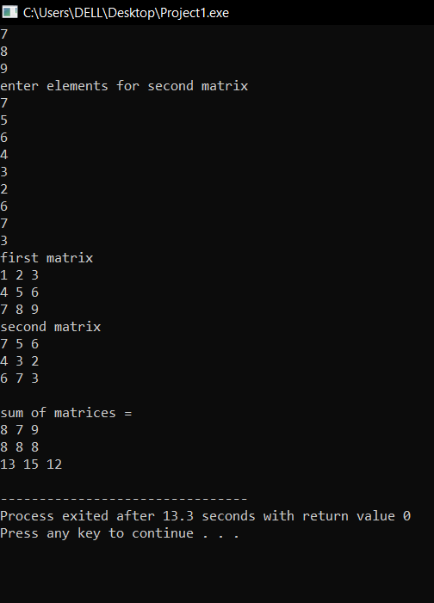

LAB TASK 3

#include <iostream>

using namespace std;

int transpose(int array[3][3],int array0[3][3]){

for(int i=0;i<3;i++){

for(int j=0;j<3;j++){

cout<<array0[i][j]<<" ";

}

cout<<endl;

}

}

int main() {

int array[3][3];

int array0[3][3]={0,0,0,0,0,0,0,0,0};

int i,j,k(0);

cout<<"enter elements\n";

for(i=0;i<3;i++){

for(j=0;j<3;j++){

cin>>array[i][j];

}

}

cout<<"your matrix is \n";

for(i=0;i<3;i++){

for(j=0;j<3;j++){

cout<<array[i][j]<<" ";

}

cout<<endl;

}

for(i=0;i<3;i++){

for(j=0;j<3;j++){

array0[i][j]=array[j][i];

}

}

cout<<"transpose of the given matrix will be \n"<<endl;

transpose(array,array0);

}

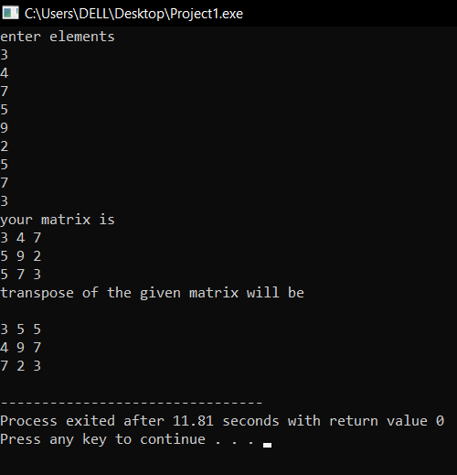

LAB TASK 4

#include <iostream>

using namespace std;

void multiply_matrices(int array1[3][3], int array2[3][3]) {

int result[3][3];

for (int i = 0; i < 3; i++) {

for (int j = 0; j < 3; j++) {

result[i][j] = 0;

for (int k = 0; k < 3; k++) {

result[i][j] += array1[i][k] * array2[k][j];

}

cout << result[i][j] << " ";

}

cout << endl;

}

}

int main() { int

array1[3][3]; int

array2[3][3];

cout << "Enter elements for first matrix:\n";

for (int i = 0; i < 3; i++) {

for (int j = 0; j < 3; j++) {

cin >> array1[i][j];

}

}

cout << "Enter elements for second matrix:\n";

for (int i = 0; i < 3; i++) {

for (int j = 0; j < 3; j++) {

cin >> array2[i][j];

}

}

cout << "First matrix:\n";

for (int i = 0; i < 3; i++) {

for (int j = 0; j < 3; j++) {

cout << array1[i][j] << " ";

}

cout << endl;

}

cout << "Second matrix:\n";

for (int i = 0; i < 3; i++) {

for (int j = 0; j < 3; j++) {

cout << array2[i][j] << " ";

}

cout << endl;

}

cout << endl;

cout << "Product of matrices:\n";

multiply_matrices(array1, array2);

return 0;

}

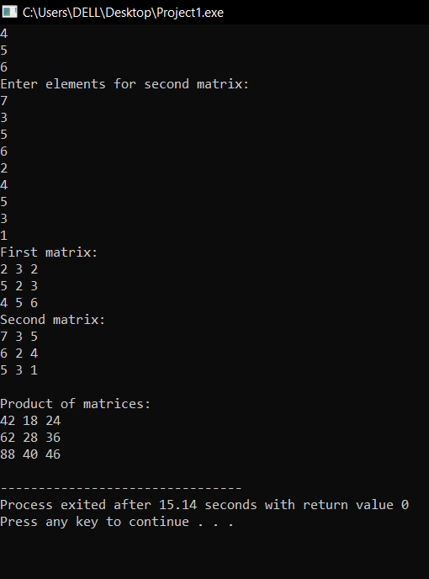

LAB TASK 5

#include <iostream>

using namespace std;

void Table(int n, int m) { if (m <= 10) { cout <<

n << " * " << m << " = " << n * m << endl;

Table(n, m + 1);

}

}

int main() { int

number = 15;

cout << "Multiplication table of " << number << ":\n";

Table(number, 1);

return 0;

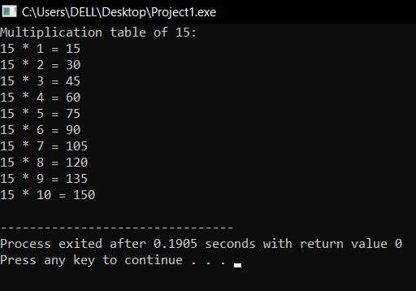

HOME TASK 1

#include <iostream>

using namespace std;

int main()

{

int i,j;

double array[3][3];

cout<<"enter array\n";

for (i=0;i<3;i++){

for(j=0;j<3;j++){

cin>>array[i][j];

}

}

cout<<"you entered \n";

for (i=0;i<3;i++){

for(j=0;j<3;j++){

cout<<array[i][j]<<" ";

}

cout<<endl;

}

double det=array[0][0] * (array[1][1] * array[2][2] - array[2][1] * array[1][2]) -

array[0][1] * (array[1][0] * array[2][2] - array[2][0] * array[1][2]) +

array[0][2] * (array[1][0] * array[2][1] - array[2][0] * array[1][1]);

double adj[3][3];

adj[0][0] = array[1][1] * array[2][2] - array[2][1] * array[1][2];

adj[0][1] = -(array[1][0] * array[2][2] - array[2][0] * array[1][2]);

adj[0][2] = array[1][0] * array[2][1] - array[2][0] * array[1][1];

adj[1][0] = -(array[0][1] * array[2][2] - array[2][1] * array[0][2]);

adj[1][1] = array[0][0] * array[2][2] - array[2][0] * array[0][2];

adj[1][2] = -(array[0][0] * array[2][1] - array[2][0] * array[0][1]);

adj[2][0] = array[0][1] * array[1][2] - array[1][1] * array[0][2];

adj[2][1] = -(array[0][0] * array[1][2] - array[1][0] * array[0][2]);

adj[2][2] = array[0][0] * array[1][1] - array[1][0] * array[0][1];

if (det == 0) {

cout << "The matrix is singular" <<endl;

}

else{

double inv[3][3];

for (int i = 0; i < 3; i++) {

for (int j = 0; j < 3; j++) {

inv[i][j] = adj[i][j] / det;

}

}

cout << "Inverse of the matrix is:" <<endl;

for (int i = 0; i < 3; ++i) {

for (int j = 0; j < 3; ++j) {

cout << inv[i][j] << " ";

}

cout <<endl;

}

}

}

